L’Epée 1839 reimagines the grace of La Regatta through Métiers d’Art
L’Epée 1839 captures the quiet elegance of rowing through a series of one-of-one Métiers d’Art reinterpretations of La Regatta, each expressing a distinct artistic vision through the timeless art of Grand Feu enameling.
Designed as a vertical clock with a clean, understated presence, La Regatta draws its long, slender silhouette from a racing skiff cutting through the water. An eight-day power reserve and precise movement reflect the strength, endurance, and disciplined control that define rowing and regatta racing.
The hull is fully adorned with Grand Feu enameling, hand-applied by David Kakabadze Enamel, a world-renowned Georgian atelier celebrated for its rare craftsmanship. In this exclusive interpretation, enameling becomes a natural continuation of the spirit of rowing. Like the repeated, fluid motion of the oar moving through water, Grand Feu enameling is a slow and careful process, built through successive firings that require patience and perfect timing. Each layer of enamel adds depth and richness, creating a surface that softly catches the light - much like water rippling under the rhythm of the boat.
Conceived to bring a sense of serenity into our often fast-paced lives, La Regatta reveals its entire gear train aligned along a single vertical axis. This architectural choice echoes the perfectly upright posture of the rower and the harmony of a crew moving in unison. Positioned at opposite ends of the clock, the barrel and escapement establish a visual and mechanical balance that mirrors the boat’s own stability on the water. In La Regatta, sport and craftsmanship come together in a calm, elegant object, where time flows with rhythm, equilibrium, precision, and grace.

The Art of Grand Feu Enamelling
The Grand Feu enameling technique is a demanding and centuries-old craft. Entirely executed by hand, the process involves applying multiple layers of colored vitrified enamel onto a metal surface, followed by successive firings at extremely high temperatures - generally between 700°C and 750°C. Each firing enhances the depth, luminosity and intensity of the color, while requiring absolute precision, as no two results can ever be identical.
The documented origins of Grand Feu enameling date back to Byzantine and Georgian arts of the 8th century, anchoring these contemporary creations in a rich historical lineage. On the Regatta, the enamel surface magnifies the sculptural lines and volumes of the piece, offering a striking contrast between mechanical horology and artisanal refinement.

Each piece explores a specific enameling technique and artistic inspiration, lending every creation its own interpretation and character:
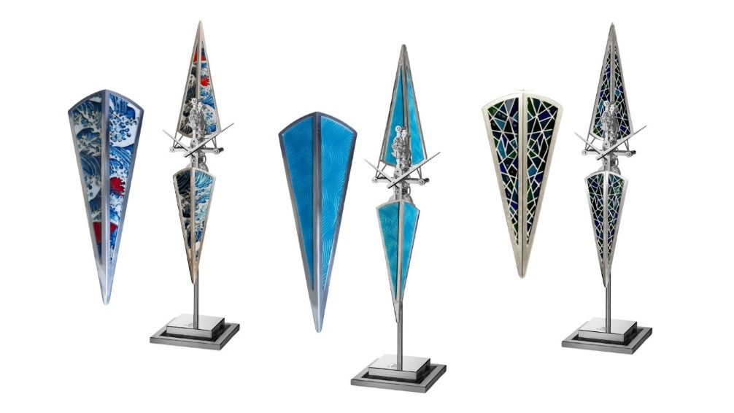
La Regatta Umi - « Sea » in Japanese
Inspired by the waves depicted in Japanese master Hokusai’s paintings, this piece features finely executed cloisonné enamel enhanced by the paillons technique, consisting of thin silver leaves inlaid in the background, capturing the rhythmic movement and power of the sea. The detailed cloisonné enamel work evokes waves rising and breaking, telling the story of La Regatta facing the elements head-on and translating the clock’s inherent elegance into a dynamic maritime expression.
Cloisonné enameling
The cloisonné technique often begins with hand-decorated metal, engraved with radiating lines or intricate curves, then coated with transparent enamel to reveal the patterns beneath. In cloisonné enameling, ultra-fine gold wires - thinner than a strand of hair - are shaped into delicate cells that are filled with enamel, color by color. Each hue, created by adding specific metal oxides, is fired separately at its ideal temperature. Some pieces demand 12 to 15 firings, as even a few seconds too long in the kiln can undo days, or weeks of painstaking work.
The paillons technique
The paillons technique is a refined enameling method valued for its luminosity and depth. Using extremely thin silver leaves placed beneath transparent enamel layers, it creates a vibrant play of light and a cooler, brighter reflection that enhances movement and visual depth.
La Regatta Blue Horizon
The Regatta returns to its minimalist silhouette, enriched by the depth of blue flinqué enameling technique. Like a vessel cutting through water, its surface subtly shifts with the light, creating optical movement that enhances the impression of motion.
Flinqué Enameling
Flinqué Enameling is a rare Métiers d’Art technique that combines guilloché engraving with translucent enamel. Finely engraved geometric patterns are coated with layers of colored enamel, allowing the decoration beneath to remain visible and giving the surface exceptional depth and luminosity. Mastery of this technique demands absolute precision, as each layer is fired multiple times at high temperatures, with no margin for error.
La Regatta Prism
In this interpretation of La Regatta, prism pattern introduces a dynamic, almost mosaic-like rhythm that contrasts with the clock’s pure, vertical architecture. Applied using the plique-à-jour enameling technique, the interplay of deep blues and greens evokes shifting reflections on water, while the structured geometry echoes both the precision of the sport and the rigour of mechanical engineering. The technique adds a vibrant, expressive dimension to the piece, while preserving its inherent sense of balance and discipline.
Plique-à-jour enamelling
Plique-à-jour enameling is among the most challenging techniques in haute horlogerie. Inspired by stained-glass windows, it requires the creation of an ultra-fine metal framework into which translucent enamel is meticulously applied. Fired multiple times at extreme temperatures without a solid backing, each element risks cracking, collapsing, or deforming—making every successful piece the result of extraordinary precision, patience, and mastery. The final result is a rare play of light, depth, and transparency, achievable only through exceptional craftsmanship.
A Collaboration with David Kakabadze Enamel
David Kakabadze Enamel is a family-owned enameling workshop founded in Tbilisi, Georgia, by David Kakabadze Jr., grandson of the prominent modernist artist David Kakabadze Sr. The latter was a painter, film director, stage designer and inventor — notably of glassless stereo cinema — who spent much of his career in France between 1919 and 1927, exhibiting regularly at the Salon des Indépendants in Paris and with works held in the Société Anonyme Collection at the Brooklyn Museum.
Today, David Kakabadze Enamel is internationally recognized for producing cloisonné panels for table clocks and dials for wristwatches for some of the world’s most prestigious watchmakers. The atelier is renowned for its exceptional versatility, mastering all major enameling techniques — cloisonné, painted enamel, transparent enamel, two-sided enamel, engraving, filigree and micromosaic — and working with platinum, gold, silver and brass. Its creations range from watch dials and jewelry to decorative and religious art, each crafted as a singular masterpiece.

Technical specifications

Unique piece 1 of 1: Customizable on demand

Dimensions: 518 mm high, base 120 mm square
Display: Hours and minutes
MOVEMENT

L’Epée 1839 in-house caliber
Escapement: 2.5 Hz/18,000 bph
No. of jewels: 26 jewels
Power reserve: 8-days
Materials: Palladium-plated brass, polished stainless steel,
Balance protection: Incabloc protection system

MATERIALS & FINISHING

Palladium-plated brass
Stainless steel
Aluminium
Finish: polished, satin brushed, sandblasted.
THE SKIFF

Materials: enamel, copper, gold wires, silver leaves

L’EPEE 1839 - Switzerland's leading clock manufacture
L’Epée has been a prominent clockmaking firm for more than 180 years. Today, it is the only manufacture in Switzerland to specialize in the production of high-end clocks. Founded in 1839 by Auguste L’Epée in France’s Besançon region, the company originally focused on producing music boxes and watch components. Even at this early stage, the brand was synonymous with entirely hand-made pieces.
Starting in 1850, the manufacture became a leader in producing escapements and began to develop special regulators for alarm clocks, table clocks and musical watches. It gained wide recognition and filed numerous patents for special escapements, particularly for use in its anti-knocking, auto-starting and constant force systems. L’Epée became the principal supplier of several famous clockmakers and went on to win many gold medals at World Fairs.
During the 20th century, the firm owed its success largely to its remarkable travel clocks. Many associate the L’Epée brand with influential individuals and people in positions of power. Members of the French government often gave clocks to their distinguished guests. When the Concorde supersonic airplane began its commercial flights in 1976, L’Epée fitted the cabins with wall clocks to give passengers the time. In 1994, the brand demonstrated its penchant for challenges by constructing the largest pendulum clock in the world, the “Giant Regulator”, which features in the Guinness Book of Records.
L’Epée 1839 is currently based in Delémont in the Swiss Jura Mountains. With CEO Arnaud Nicolas at the helm, it has developed an exceptional collection of table clocks that includes an entire range of sophisticated clocks.
The collection focuses on three themes:
Creative Art - Artistic pieces first and foremost, often developed in partnership with external designers as joint creations. These clocks surprise, inspire and even shock the most seasoned collectors. They are intended for those consciously or unconsciously looking for exceptional objects that are one of a kind.
Contemporary Timepieces - Technical creations with a contemporary design (Le Duel, Duet, etc.) and minimalist, avant-garde models (La Tour) incorporating complications such as retrograde seconds, power reserve indicators, moon phases, tourbillons, chiming mechanisms or perpetual calendars.
Carriage Clocks - Lastly, classic travel clocks, also known as “officers’ clocks”. These historical pieces issued from the brand’s heritage also feature their fair share of complications: chiming mechanisms, minute repeaters, calendars, moon phases, tourbillons and more.
All pieces are designed and manufactured in-house. Their technical prowess, combination of Form and Function, very long power reserves and remarkable finishes have become signature features of the brand.

